# Compare arrays in Python

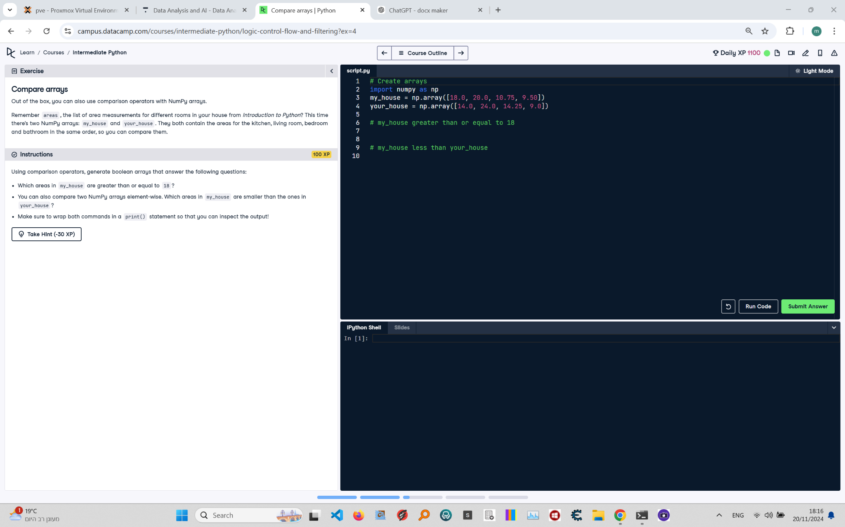

**Question:**

Using comparison operators, generate boolean arrays that answer the following questions:  
1. Which areas in `my_house` are greater than or equal to 18?  
2. Which areas in `my_house` are smaller than the ones in `your_house`?  
Make sure to wrap both commands in a `print()` statement so that you can inspect the output!

**Answer:**

Here is the Python code that solves the problem:

# Create arrays  
import numpy as np  
  
my_house = np.array([18.0, 20.0, 10.75, 9.50])  
your_house = np.array([14.0, 24.0, 14.25, 9.0])  
  
# my_house greater than or equal to 18  
print(my_house >= 18)  
  
# my_house less than your_house  
print(my_house < your_house)

**Explanation of the Code:**

1. **Importing numpy library**: The numpy library is imported to perform array-based operations.  
2. **Define `my_house` and `your_house` arrays**: These arrays represent the areas for different rooms in two houses.  
3. **Comparison operation (greater than or equal to)**: The code `my_house >= 18` generates a boolean array that indicates which elements of `my_house` are greater than or equal to 18.  
4. **Comparison operation (less than)**: The code `my_house < your_house` compares elements of `my_house` and `your_house` element-wise, returning a boolean array indicating which elements of `my_house` are smaller than the corresponding elements in `your_house`.  
5. **Printing the results**: The results of both comparisons are printed for inspection.